Collaborative Conflict Management in the Workplace
Scenario Background and Simulation Preparation

Getting Ready for the Online Simulation

- The Collaborative Conflict Management Simulation will be conducted online via a Zoom meeting link, which will be sent to your Walden email prior to your scheduled simulation time. In preparation for your simulation experience, consider the following technical aspects of the simulations:

  - Find a location with reliable internet connectivity and minimal background noise. If you have the ability to create a hard connection to your internet, i.e. using an Ethernet cord, you may wish to do so to ensure your connectivity is reliable.
  - Use a computer or laptop with a webcam and screen large enough to view the avatars well. Note: The avatars can see you and respond to you in real time.
  - Check the microphone and speakers on your computer or laptop to ensure they are at a volume at which you can hear and speak to the avatars clearly. You may wish to use a headset with a microphone for a better listening and recording experience.

- Your simulation will be recorded and a link to your recording will be sent to you following the completion of the simulation experience.

The Simulation Scenario

Lee, an experienced employee at Global ProTech, has recently been transferred to a new manager. In past years, Lee’s performance reviews have been stellar. He has been recognized for professional commitment to the company, superior talent and skills, communication and collaboration strengths, and the ability to perform on budget and on time. Linda, his new manager, was looking forward to having Lee on her team and so far, she has not been disappointed in his performance. Lately, however, Lee has been sporadic in his arrival time; often coming in later than the other employees on the team; sometimes leaving earlier; sometimes staying later. Her observations show that he is still putting in the correct number of hours per week but even so she feels she needs to be able to count on Lee to be at work “on time,” not only for the skills he brings to the team but also because she wants him to be a role model for others.

Linda is aware that there is a flex-time arrival policy in place at Global ProTech but she is still finding it difficult to let Lee “come and go as he pleases.” She is concerned about whether the other employees on the team will think that she is giving Lee special treatment because he has been with the company for years. She also does not want anyone else to adopt a cavalier attitude when it comes to getting to work “on time.” She has approached Lee about this twice, but both times he seemed to withdraw, and avoided(?) answering her directly as to why he comes in on time some of the time and then, unpredictably, gets to work an hour or so later on other days. Last time they spoke, he looked down and quietly mentioned, “flex-time,” looked at her apologetically, and went to his desk where he diligently got down to work.

Linda astutely realizes that her frustration with the situation may spill over to how she views the quality of Lee’s work and so decides to come to you, her HR professional, to get help talking with Lee in order to manage what is escalating into a conflict. You invite both Linda and Lee to a meeting to work this through together. In Lee’s response to the invite, you learn that he has been late because he has taken on the challenging role of caring for an elderly parent.

Your challenge as Human Resources Manager is to meet with Linda and Lee to foster communication between the two, encourage Lee to confide his situation to Linda, and help them both manage this conflict and reach an agreement about arrival and departure times before the situation intensifies. As you prepare for the meeting, you make sure you have a copy of Global ProTech’s flex-time policy and your meeting notes.

Simulation Challenges and Objectives
Important Note: In the simulation experience, you will not be notified when you have met or not met a challenge and its objective. However, the avatar will respond by becoming more engaged in the conversation when you “hit” the challenge and will react in a more disengaged manner if you “miss” the challenge. If you would like to keep track on your own, you may wish to have this document and your Week 5 Meeting Notes Assignment available as you complete the simulation experience.

- Challenge 1: Use facilitation skills/active listening to begin the meeting by greeting both the manager and the employee, creating a safe space to foster open dialogue, and discussing the purpose of the meeting.

Performance Objective for Challenge 1: Create a safe atmosphere for everyone in order to encourage them to engage.

- Challenge 2: Use active listening skills as you begin the process of guiding the collaborative conflict management process. This includes asking each party to share the issue from his/her perspective, acknowledging that you are listening to each person’s perspective by asking questions and/or paraphrasing, and demonstrating appropriate body language.

Performance Objective for Challenge 2: Draw both Lee and Linda into the conversation in a positive way so they each share their perspective on the issue.

- Challenge 3: Share the Global ProTech flextime policy, use active listening skills, and based on based on both people’s perspectives and the corporate flextime policy, present a solution that respects both people’s needs.

- Share the flextime policy
- Point out the overlaps in the employee and manager’s perspectives and the flextime policy
- Present a solution that respects both people’s needs.

Performance Objective for Challenge 3: This challenge has multiple objectives of supporting/sharing the company flextime policy, making both people feel heard and acknowledged, and presenting a solution that respects both people’s needs.

- Challenge 4: End the meeting cordially, summarize what took place, create a plan that establishes a check-in for progress.

Performance Objective for Challenge 4: Obtain cooperative statements from Lee and Linda and agreement to the plan.

Simulation Preparation
- Review the Week 7 Discussion requirements and view the introductory and sample simulation videos in the Week 5 Learning Resources as well as all of the simulations resources and documents. Be sure to familiarize yourself with the technical aspects of the online simulation.
- Complete your Week 5 Meeting Notes Assignment.
- Keep in mind, you will not be assessed on your performance, rather this exercise is a tool for practice and reflection on facilitating conflict management in the workplace.

The CANs and CANNOTs of the Avatars
- The avatars CAN:
- Interact with and respond to you in real time while experiencing a wide range of emotions
- See you and hear you
- Improvise according to what they know or don’t know

The avatars CANNOT:
- Perform certain physical functions such as switching seats, standing up, leaving the room, etc.

Meet the Avatars
The following information provides insight into the different avatars you will engage with or observe during the simulation experience. Be sure to review the information prior to your experience to get to know the avatars and familiarize yourself with their backstories.

Bennett
You will begin your simulation with a welcome from Bennet, our Simulation Guide. He will greet you prior to your simulation and he will explain the simulation protocols. Bennet will always be standing by during your simulation if you run into any technical dificulties. At the end of your simulation, you will be reunited with Bennet to breifly reflect on your experience.

Lee and Linda
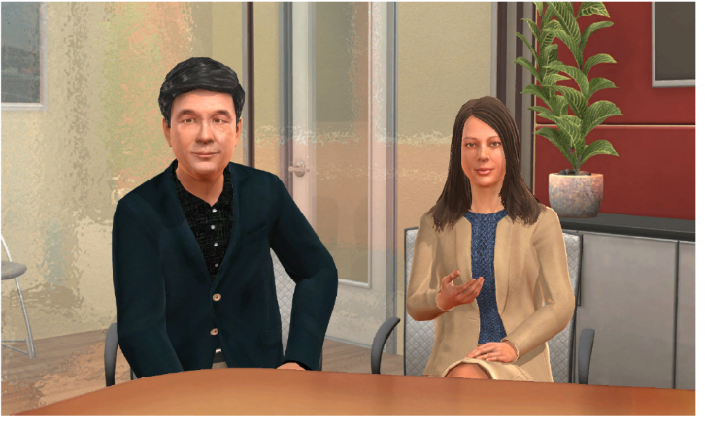
Lee, on the left, will be the avator representing the Global Proteach Employee and Linda, on the right, will be the avatar representing Lee’s manager. Once Lee and Linda appear on your screen, your simulation will begin and your opportunity to practice collaborative conflict management and active listening will begin.

